TASK 5:

**-- Task 5: SQL-Based Product Sales Analysis (Chinook DB)**

**-- 1. Top-Selling Tracks (Products)**

SELECT

Track.Name AS ProductName,

SUM(InvoiceLine.Quantity) AS UnitsSold

FROM InvoiceLine

JOIN Track ON InvoiceLine.TrackId = Track.TrackId

GROUP BY ProductName

ORDER BY UnitsSold DESC

LIMIT 10;

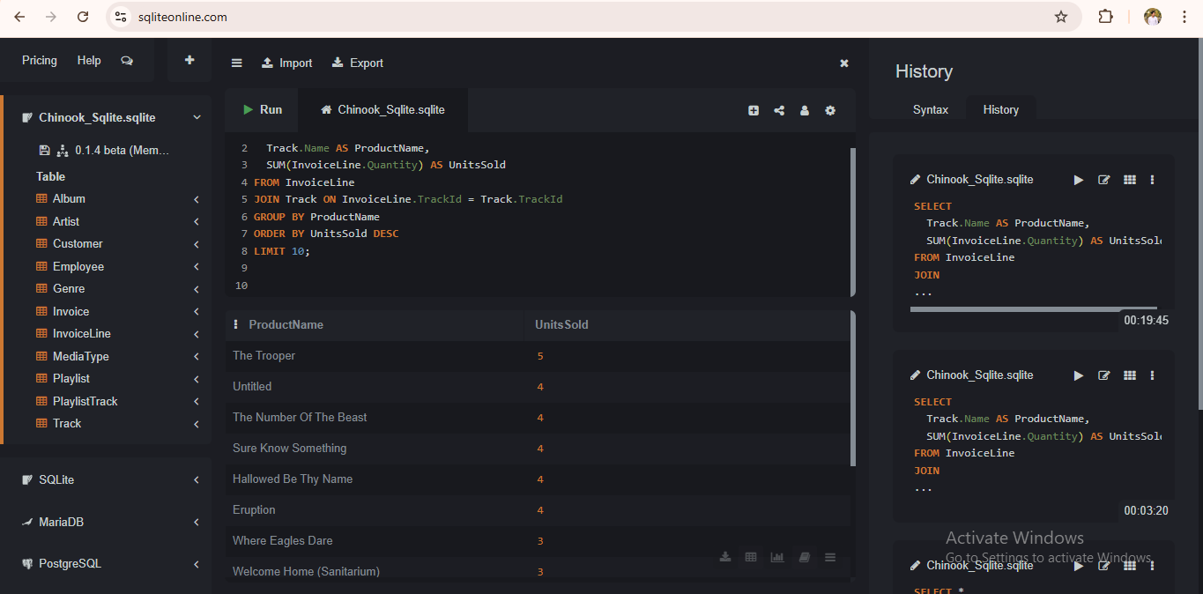

**-- 2. Revenue by Country**

SELECT

Customer.Country,

ROUND(SUM(Invoice.Total), 2) AS TotalRevenue

FROM Invoice

JOIN Customer ON Invoice.CustomerId = Customer.CustomerId

GROUP BY Customer.Country

ORDER BY TotalRevenue DESC;

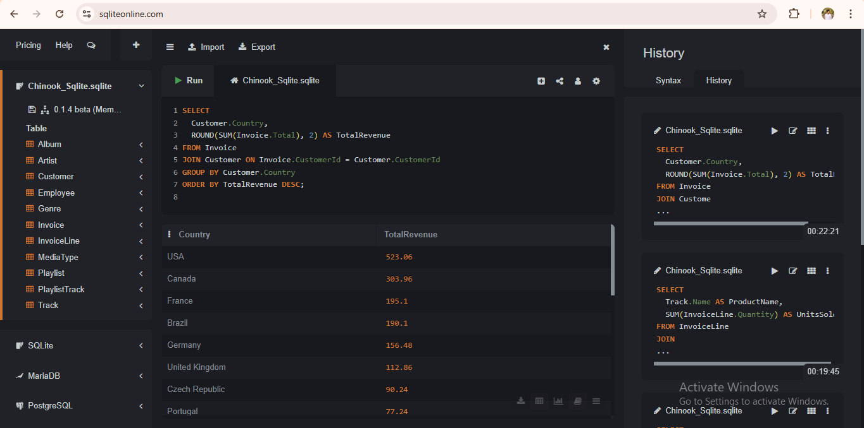

**-- 3. Monthly Sales Trend**

SELECT

SUBSTR(InvoiceDate, 1, 7) AS Month, -- yyyy-MM format

ROUND(SUM(Total), 2) AS MonthlyRevenue

FROM Invoice

GROUP BY Month

ORDER BY Month;

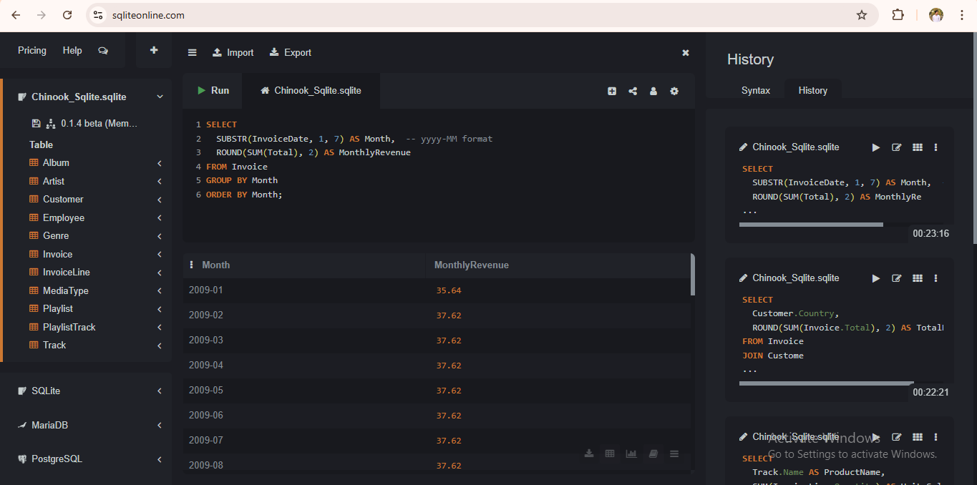

**-- 4. Top Artists by Units Sold**

SELECT

Artist.Name AS ArtistName,

SUM(InvoiceLine.Quantity) AS UnitsSold

FROM InvoiceLine

JOIN Track ON InvoiceLine.TrackId = Track.TrackId

JOIN Album ON Track.AlbumId = Album.AlbumId

JOIN Artist ON Album.ArtistId = Artist.ArtistId

GROUP BY ArtistName

ORDER BY UnitsSold DESC

LIMIT 10;

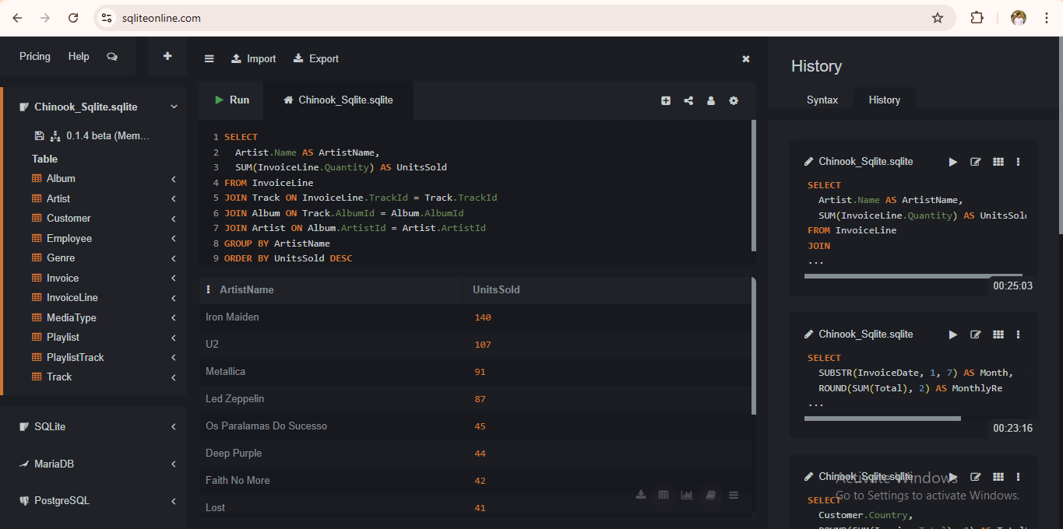

**-- 5. Best Customers by Spend**

SELECT

Customer.FirstName || ' ' || Customer.LastName AS CustomerName,

ROUND(SUM(Invoice.Total), 2) AS TotalSpent

FROM Invoice

JOIN Customer ON Invoice.CustomerId = Customer.CustomerId

GROUP BY Customer.CustomerId

ORDER BY TotalSpent DESC

LIMIT 10;

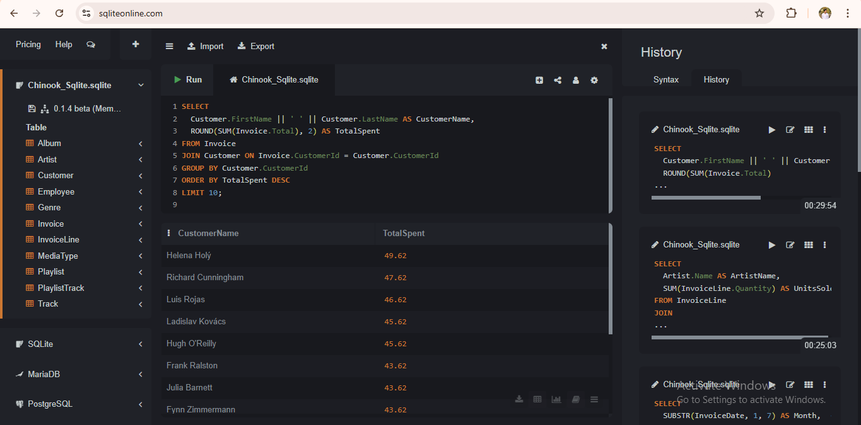

**-- 6. Bonus: Top 5 Customers per Country using ROW_NUMBER()**

SELECT *

FROM (

SELECT

Customer.Country,

Customer.FirstName || ' ' || Customer.LastName AS CustomerName,

ROUND(SUM(Invoice.Total), 2) AS TotalSpent,

ROW_NUMBER() OVER (PARTITION BY Customer.Country ORDER BY SUM(Invoice.Total) DESC) AS RankInCountry

FROM Invoice

JOIN Customer ON Invoice.CustomerId = Customer.CustomerId

GROUP BY Customer.CustomerId

)

WHERE RankInCountry <= 5;

